CHAPTER 1

INTRODUCTION

- Introduction

In the world we live in, technology is developing every day. With the development of technology, many modern electronic devices have been produced for humans. Among these things, our website may do things like sell and repair certain electronic products. Some electronic products of the users are also exchanged.
This system is basically a web-based application that is built in PHP, Html, Bootstrap, CSS, javascript, and jQuery. And for the backend of the system, SQL server has been used (i.e. Database) so that it will be easy to retrieve later. Also, the main aim of the system is to help the user to easily view, buy and exchange products.

- Objectives of the System

  - To know about update new information of TV, refrigerators, fan, washing machine which is available in website.
  - To make customers easy to find about TV, refrigerators, fan, washing machine and aircon and to buy them easily.
  - To satisfy the customers by exchanging the unnecessary items of the buyers.
  - To enable customers to choose their preferred service teams.

CHAPTER 2

IMPLEMENTATION OF THE SYSTEM

- User Implementation

- Home Page

The top left corner of this page includes our system title “Electronic Service System”. The top right corner of this page includes Home, Service & product, About, Contact and Login navigation links. In our system, there are four main types of machines that can be repaired, namely aircon, TV, refrigerator, washing machine. The picture of home page is shown in figure 2.1.1.

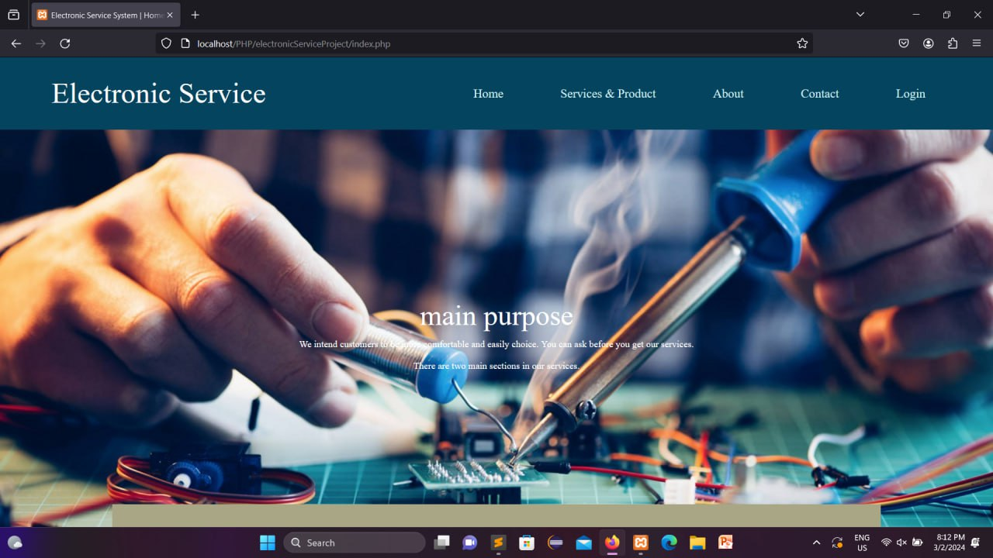
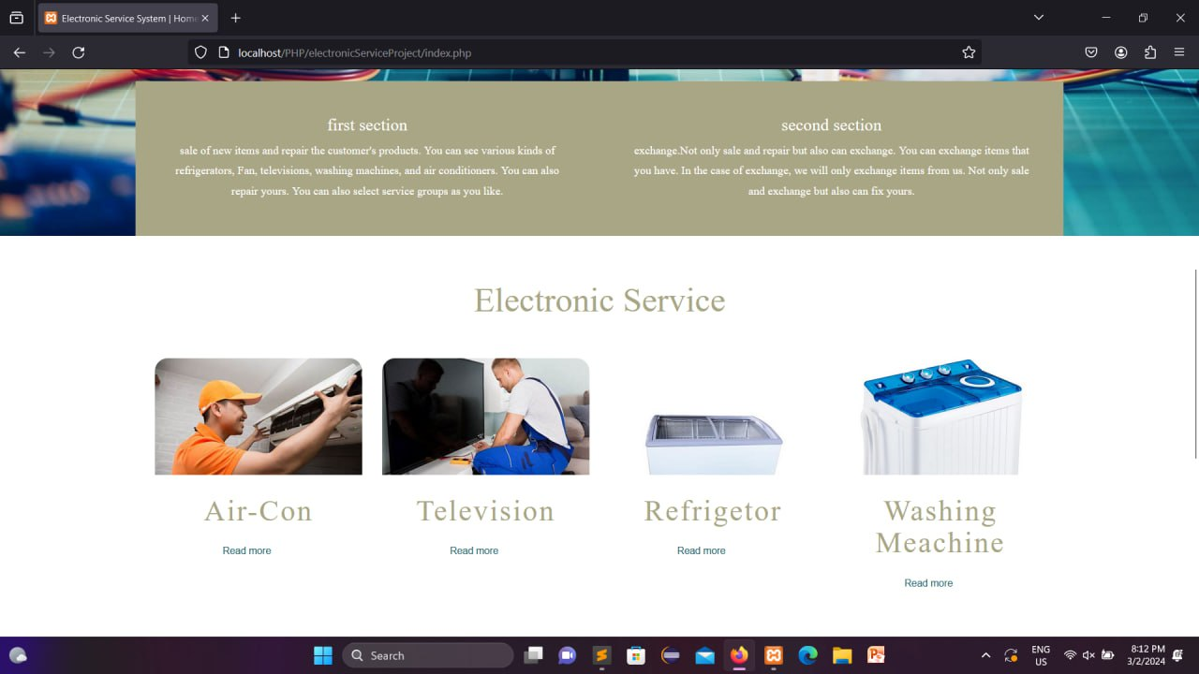
Figure 2.1.1 Home Page
- Login & Sing up Page

Users need to enter email and password to login. If users haven't registered, click sign up now and register.

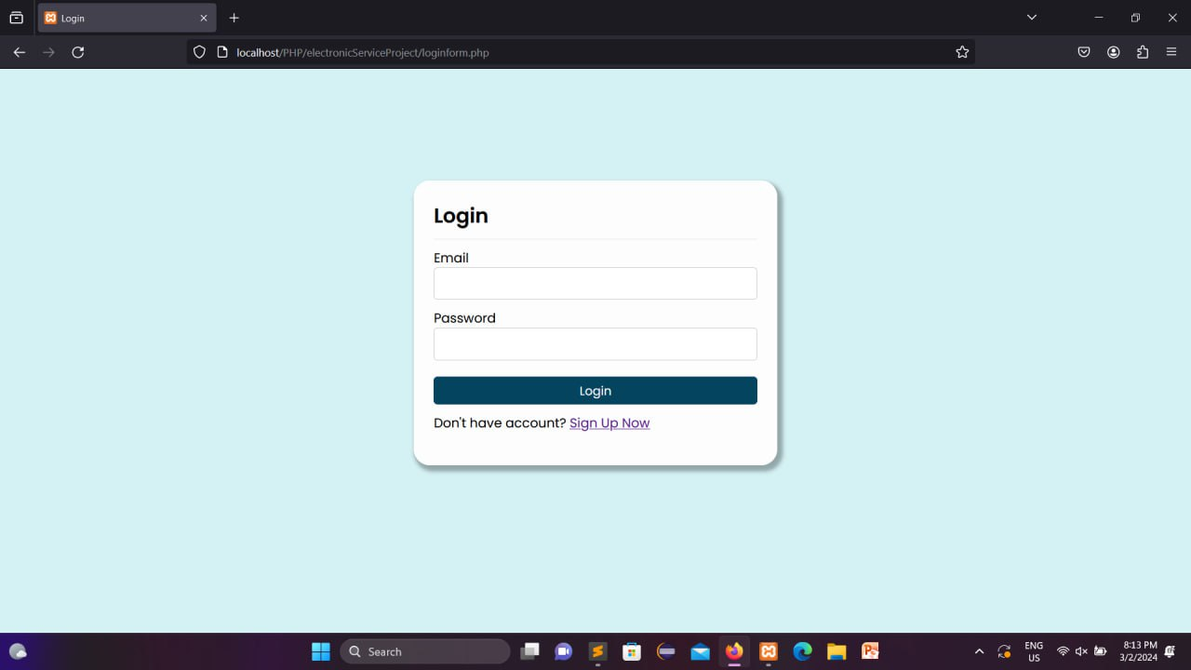

Figure 2.1.2 Login & Sing up Page

- Service Page

There are four main types of service that can be repaired, namely aircon service, TV, service , refrigerator service, washing machine service.

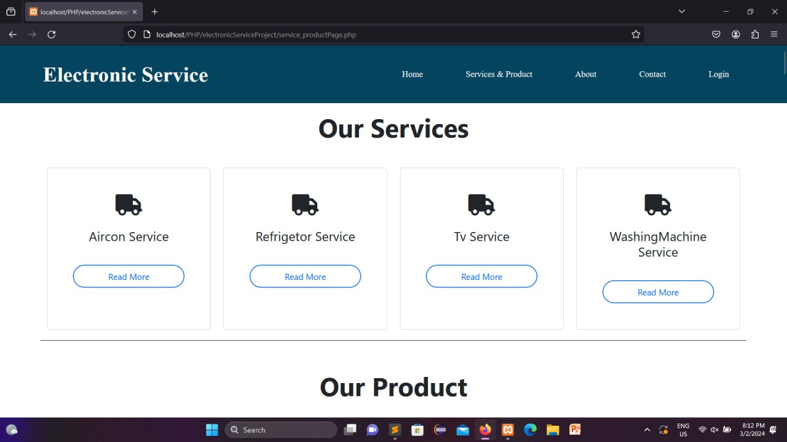

Figure 2.1.3 Service Page

- Product Page

The brand name and price of the items will be listed. There will be three buttons such as buy now exchange send.

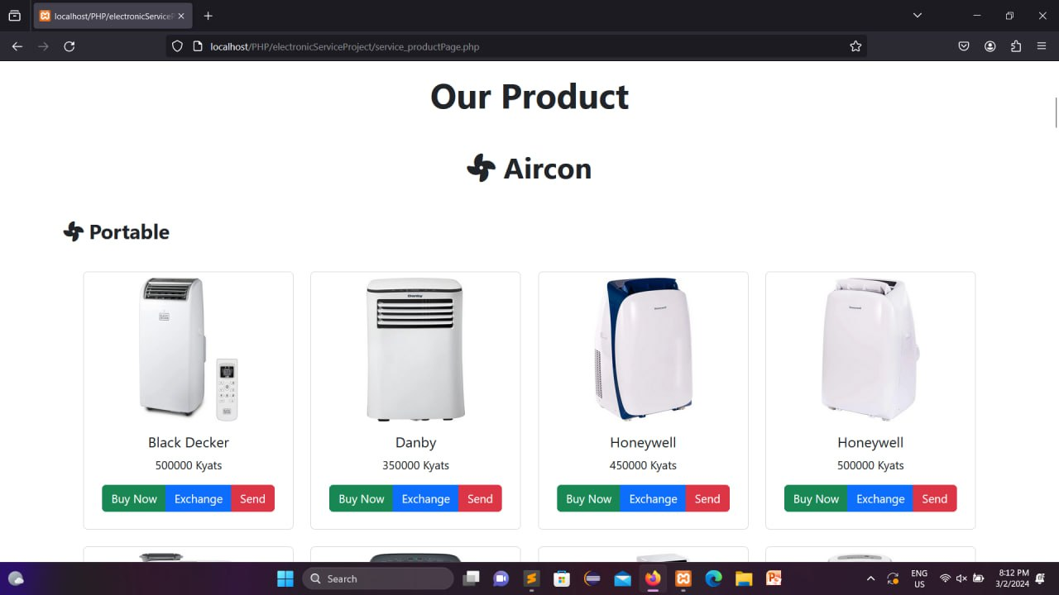

Figure 2.1.3 Product Page

- Choose service staff Page

Users can choose service staff who are working for free.

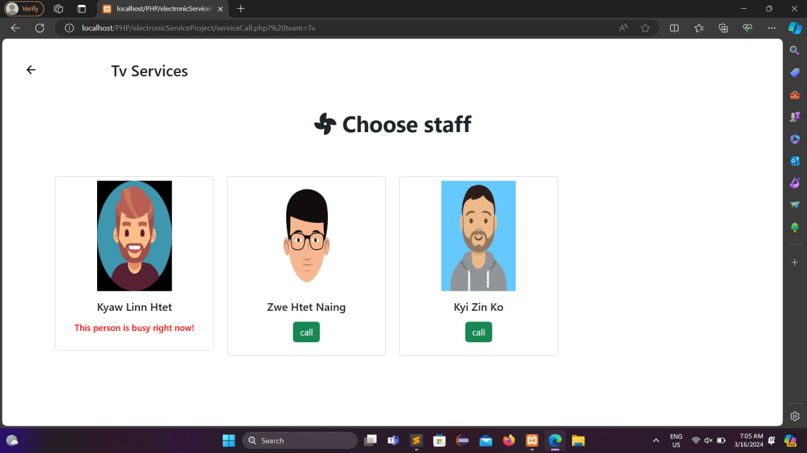

Figure 2.1.5 Choose service staff Page

- Service Call Form Page

If users want to call for service by filling out the form with user’s full name and address.

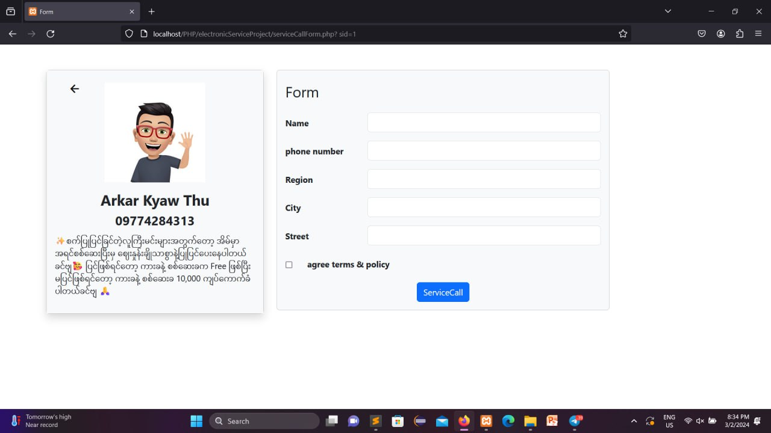

Figure 2.1.6 Service Call Form Page

- Exchange Form Page

In this page, users need to fill the picture of the item, brand name, year of purchase, and description if they want to exchange.
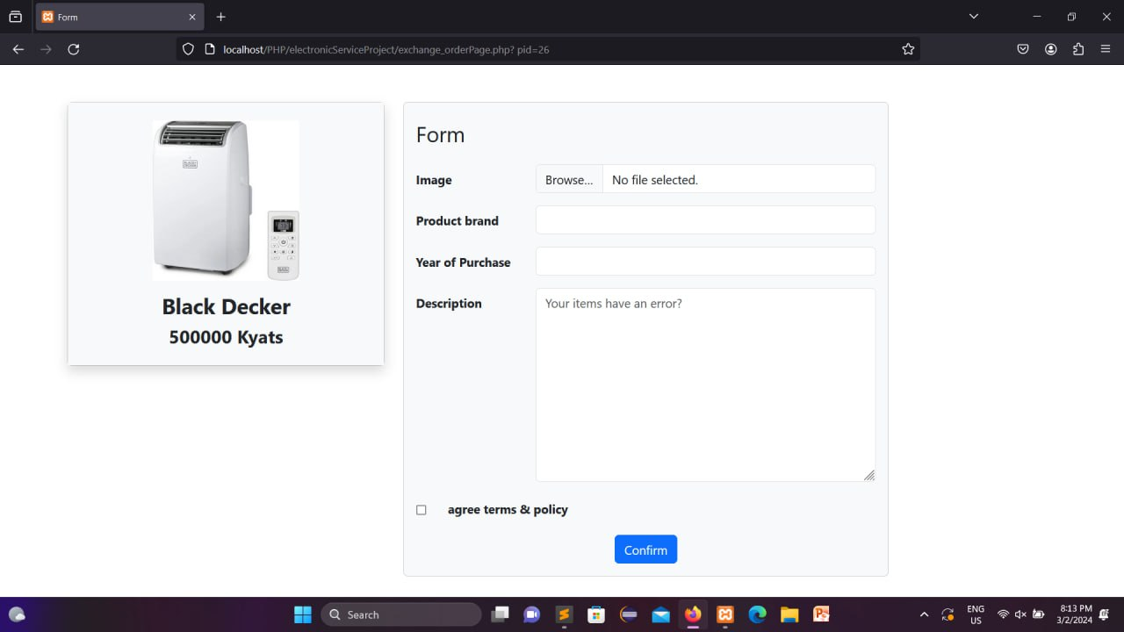
Figure 2.1.7 Exchange Form Page
- Buy Now Form Page

In this page, users need to fill name, phone number, region, city, street if they want to buy.
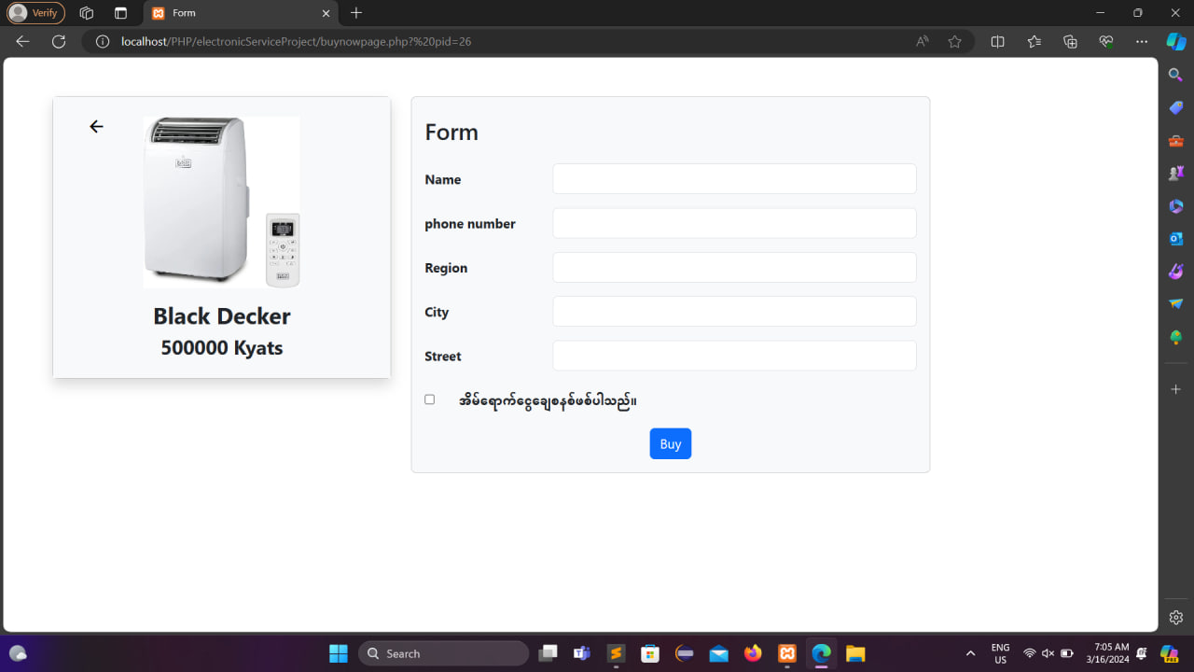
Figure 2.1.8 Buy Now Form Page

- Profile & Notification Page

User can see their email, address, phone number and notification of those who have signed in the profile page. They can also check notification of exchange items.

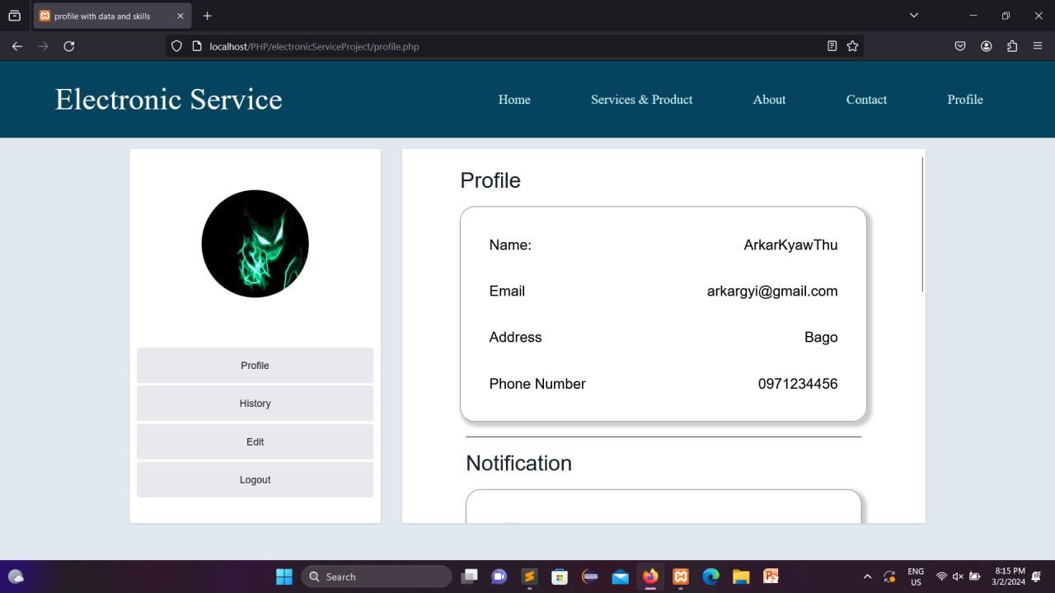

Figure 2.1.9 Profile & Notification Page

- History Page

In history page, user can see their details of purchased items.

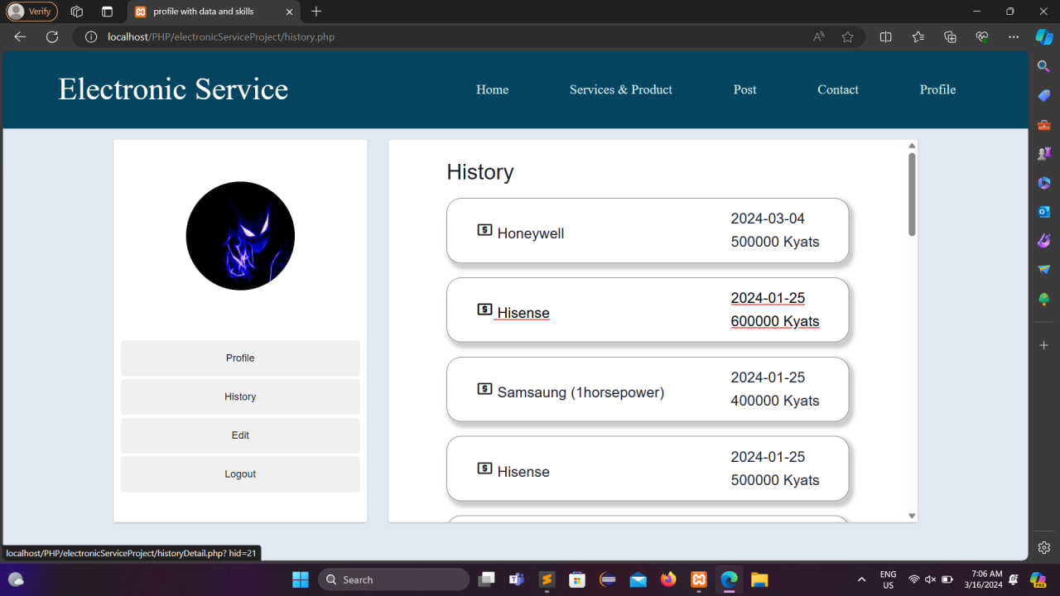

Figure 2.1.10 History Page

- Admin Implementation

  - Admin Dashboard Page

In the admin section, the monthly income outcome exchange orders and the number of items that have already been sold are shown in a bar chart.
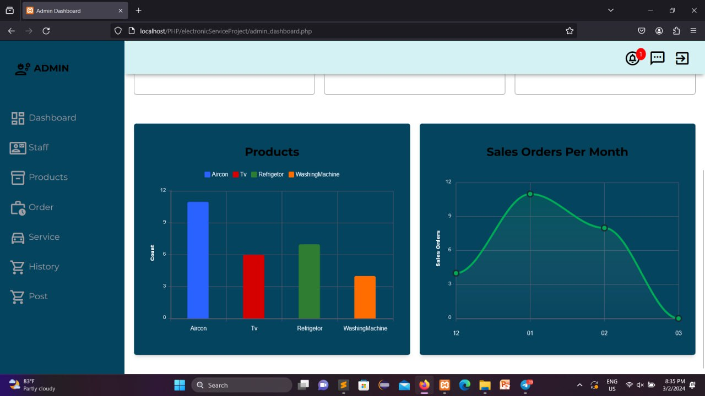

Figure 2.2.1 Admin Dashboard Page
  - Post Page

Admin can post news about products and content.

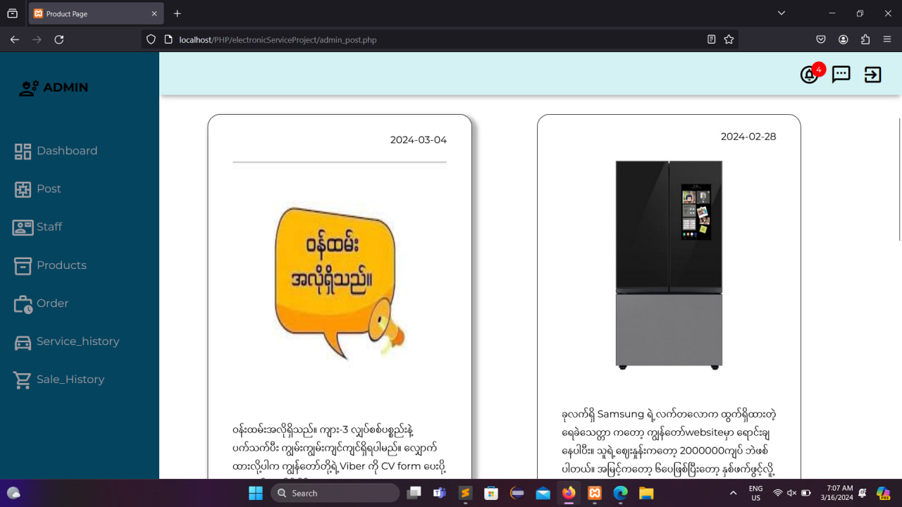

Figure 2.2.2 Post Page

  - Staff Page

In this page, complete information of the staff and functions that can be edited and removed that have been added. Admin can also add new staff.

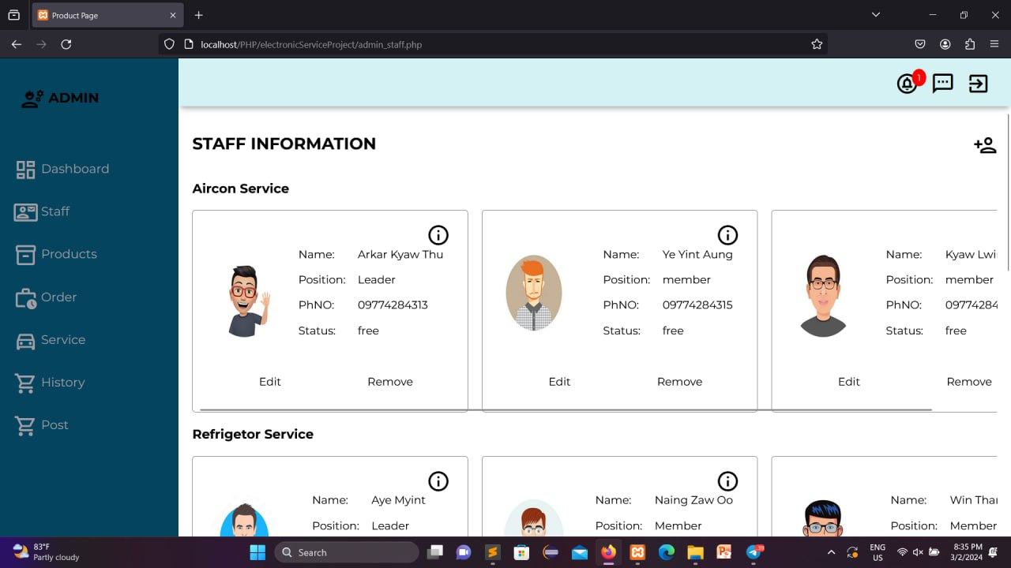

Figure 2.2.3 Staff Page

  - Products Page

In this page, information of the products and functions that can be edited and removed that have been added. Admin can also add new products.

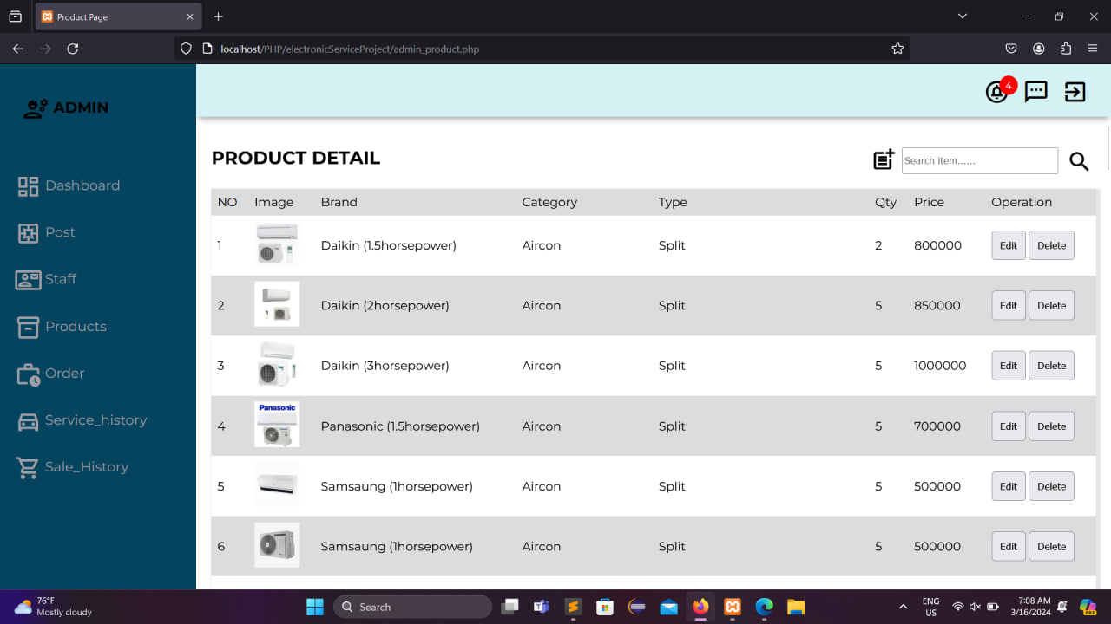

Figure 2.2.4 Products Page

  - Order Page

Admin can view and confirm customer exchanged order.

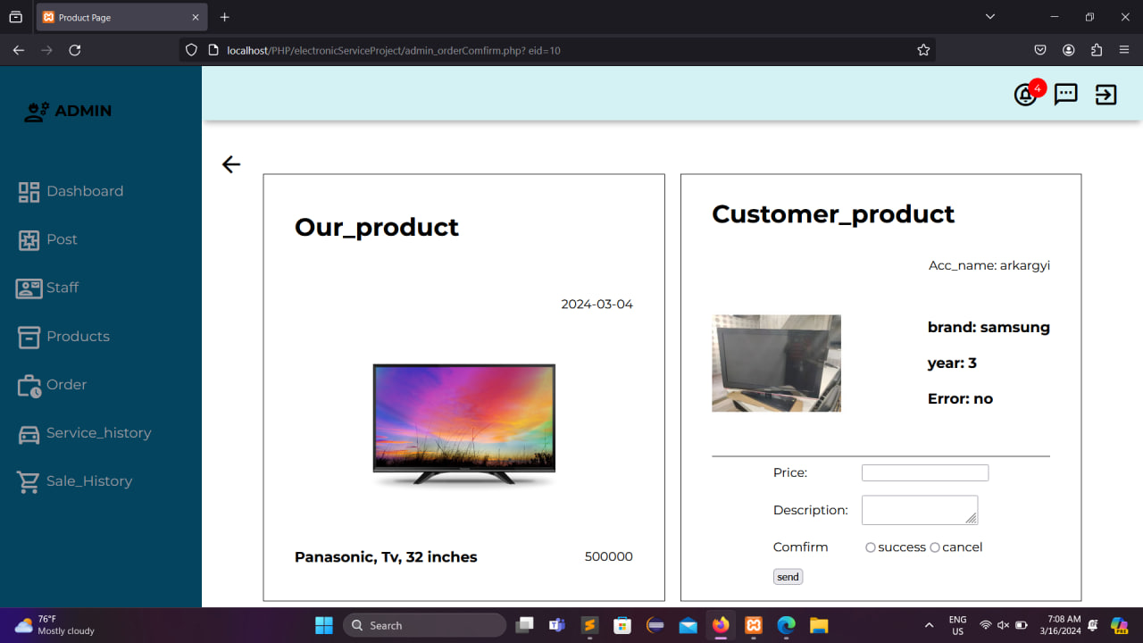

Figure 2.2.7 Order Page

  - Service History Page

Admin can view customer’s history of call services.

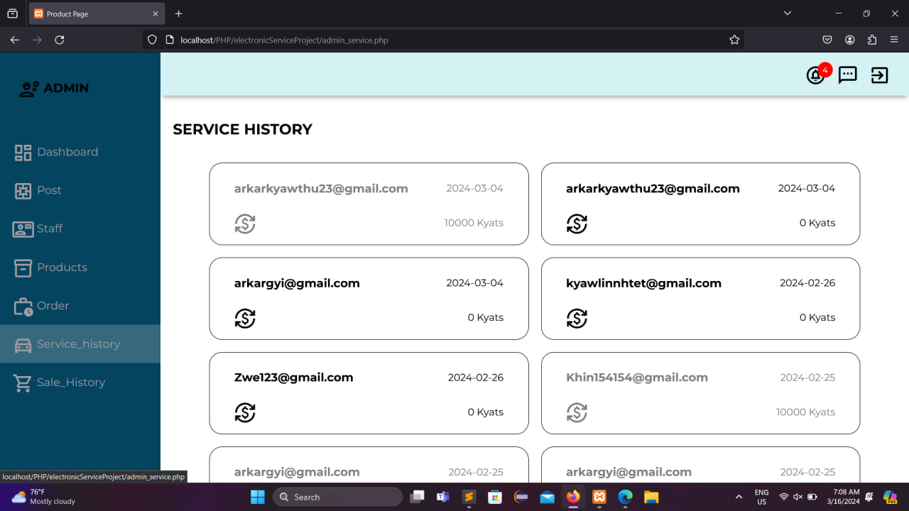

Figure 2.2.6 Service History Page

  - Sale History Page

Admin can view customer’s history of purchased and exchange items.

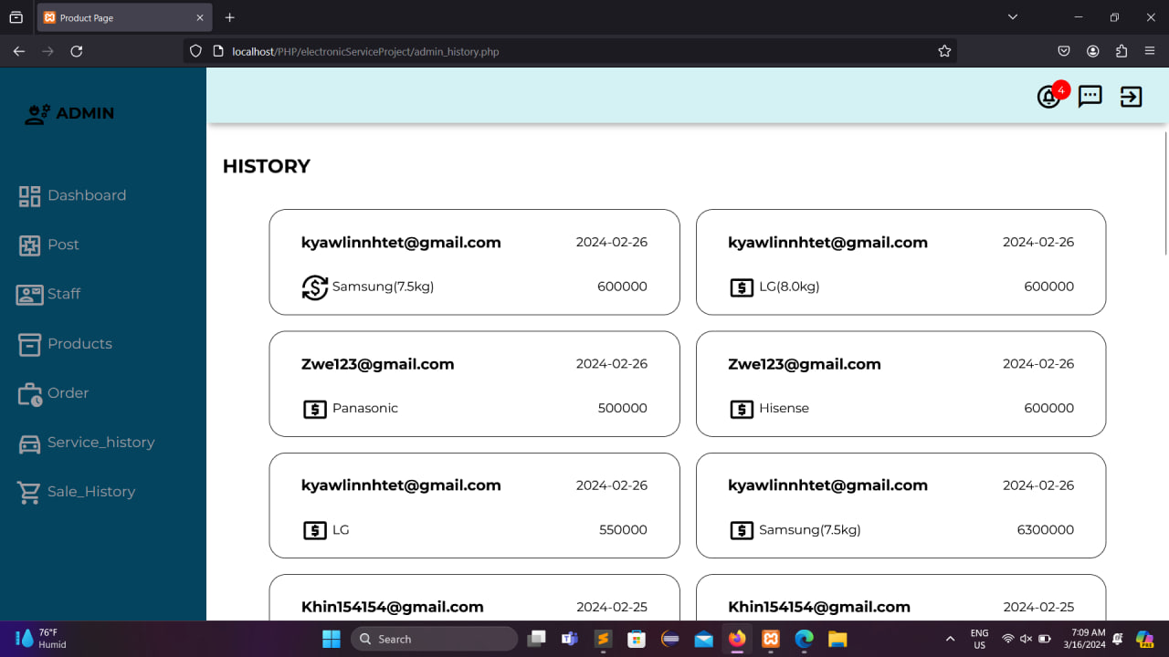

Figure 2.2.7 Sale History Page

CHAPTER 3

CONCLUSION

Nowadays, many people are using modern electronic products. Those electrical appliances are also necessary in some places. On our website, you can find some of these electrical appliances at low prices and good service.

- Advantages of the system

Electronic service website has many advantages for customers. By using this website, you can save time and labor and buy the equipment you want from home at a low price. In addition, 0 services can be easily accessed. In this system, buyers can exchange their old items for new items for money. There's no need to worry about getting scammed because it's a home payment system.

References
- www.panasonic.com
- www.w3school.com

